Name

Mathematics Stage 5 Core
Grouped Data

Book 1 | Grouped data | Version: 260419  Feedback:  https://MrDingMaths.com
Contents
Grouped Frequency Tables 2
Grouped Histograms 8
Mean and Median from Grouped Data 11

Grouped Frequency Tables

- Grouped Data
When handling many numerical values, we group them into intervals called classes to spot patterns more easily.
Grouping data can reveal trends, but individual data values are lost.

- Investigation Grouping data into classes
Change this frequency table into a grouped frequency table.
  Minutes | Frequency
  20 | 1
  25 | 2
  28 | 1
  30 | 4
  32 | 1
  35 | 3
  38 | 2
  40 | 5
  42 | 1
  45 | 3
  48 | 2
  50 | 3
  55 | 1
  60 | 1
  Total | 30
  Class | Frequency
  20–29
  30–39
  40–49
  50–59
  60–69
  Total | 30
What data was lost due to grouping the data?

Where is the data clustered?

- Investigation Grouping data into classes
The heights of students were measured in cm:
160, 152, 159, 166, 177, 142, 133, 135, 162,
158, 145, 134, 179, 181, 152, 132, 144, 131

Choose appropriate classes:
- What is the minimum and maximum values?
- How wide should each class be?
- Make sure every value fits into exactly one class. No gaps or overlaps.
Complete the table and answer the questions:
Height (cm) | Frequency
- How many students were surveyed?

- What was the most frequent class? (modal class)

- What was the least frequent class?

- How many people are 170 cm or taller?

Here are the raw times (in seconds) for 25 students completing a 400m race:

63.2, 71.8, 58.4, 66.1, 74.3, 61.7, 69.5, 57.9, 72.6, 64.8, 78.2, 60.3, 67.4,
55.6, 73.1, 62.9, 68.7, 76.4, 59.1, 65.3, 70.8, 56.2, 63.7, 71.2, 66.9
For continuous data, classes are inequalities. The first class has been set up for you.
Time (s) | Frequency
$$55≤t<60$$

Complete the table and answer the questions.
- What was the modal class?

- How many people took longer than 65 seconds?

- Just by looking at the table, could you tell exactly what the fastest time was?

Foundation
- For each set of data, decide whether the values should be put into an ungrouped frequency table or a grouped frequency table. Explain your reasoning.
  - 1, 1, 1, 1, 1, 1, 1, 2, 2, 2, 2, 3, 3, 3, 3, 3, 3, 3
Ungrouped. Data is discrete with small range.
  - red, green, yellow, yellow, green, red, green, yellow
Ungrouped. Can’t group categorical data
  - 18, 52, 43, 55, 24, 38, 32, 41, 16, 51, 29, 35, 30, 20, 45, 54, 19, 28, 44, 40
Grouped. Many different values across a wide range.

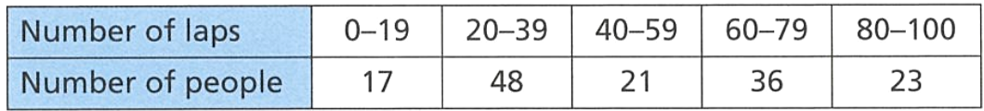
- The table shows the numbers of laps completed by people who attended an ice-skating rink last Sunday.

  - How many people completed 60-79 laps?
36
  - How many people attended the ice-skating rink in total?
145
  - How many people completed fewer than 40 laps?
65
  - Why is it impossible to tell how many people completed more than 90 laps?

We only know how many people between 80 and 100. We have lost specific values by grouping the data.

Height (cm) | Frequency
130 – 139
140 – 149
150 – 159
160 – 169
170 – 179
180 – 189
190 +
Total
- Complete this grouped frequency table.
174, 179, 161, 132, 191, 196, 138, 165, 151, 178, 189,
147, 145, 145, 139, 157, 193, 146, 169, 191, 145
  - How many people are in the range 150–159 cm?
2
  - How many people are 180 cm or taller?
5
  - How many people are between 140 cm and 169 cm tall?
10

- Complete each frequency table using the given data.
19, 18, 20, 17, 22, 19, 22, 20, 24, 18, 20, 19
Handspan (cm) | Frequency |  | Handspan (cm) | Frequency
17 |  |  | 17 – 19
18 |  |  | 20 – 22
19 |  |  | 23 – 25
20 |  |  | Total
21
22
23
24
Total

  - How many people have a handspan less than 23 cm wide?
11
  - What information has been lost due to the grouping?
Individual data points
- The marks out of 100 for students in a maths test were:

Using classes 50–59, 60–69, 70–79, 80–89, 90–99, construct a frequency table.
Mark | Frequency
Total
  - How many students scored between 70 and 79?
15
  - How many students scored less than 80?
26
  - How many students scored 70 or better?
29

Development
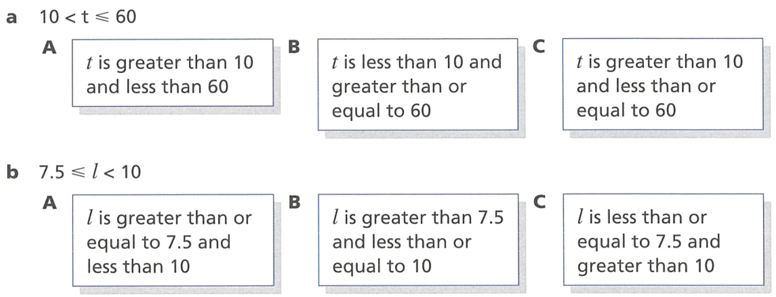
- Which statement matches each inequality?

C

A
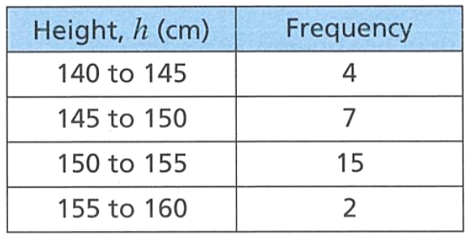
- Jun has made a table to record the heights of people in his class.

Explain why the table does not communicate information clearly.
(Hint: where would a data value of 145 go?)

The classes overlap. 145 could go into two classes.
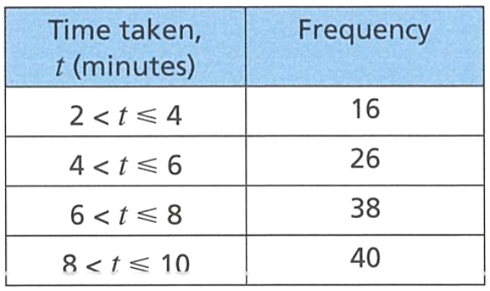
- The table shows the times taken, in minutes, to complete a puzzle.

  - Which class interval has the lowest frequency?
$$2<t≤4$$
  - How many people took longer than 8 minutes to complete the puzzle?
40
  - How many people in total completed the puzzle?
120
  - What fraction of the people took longer than 6 minutes to complete the puzzle?
13/20

- Helen wants to measure the heights of some plants. She makes the following table to record the data. Improve the table so that it can be used for continuous numerical data.
(Hint: where would 10.5 go? How can we use inequalities?)
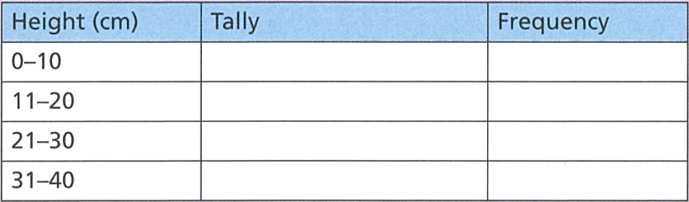

$$0<h≤10 10<h≤20 20<h≤30 30<h≤40$$
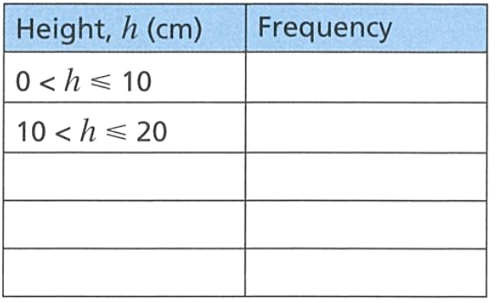
- Here are the heights of some plants. The heights are in centimetres to 1 decimal place. Complete the grouped frequency table.
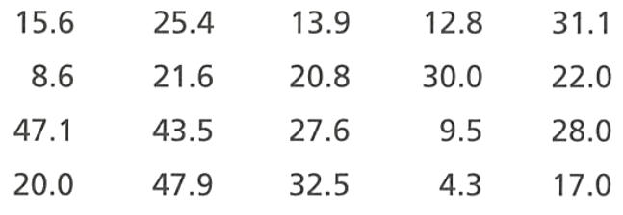

  - Which class interval has the highest frequency?
$$20<h≤30$$
  - What percentage of the plants are less than or equal to 10 cm tall?
15%
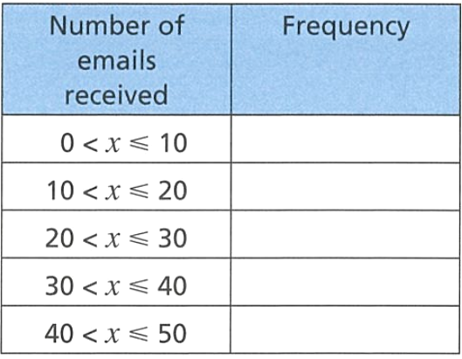
- 80 people are asked how many emails they received yesterday.
- 30 people said they received 10 or fewer emails.
- 45 people received 20 or fewer emails
- 26 people received more than 30 emails
- 2 people received more than 40 emails
Use the data to complete this table.

30, 15, 9, 24, 2

Grouped Histograms

- Review
- Calculate midpoint of two numbers
- 0 and 4 | - 5 and 9 | - 10 and 19
- 30 and 40 | - 40 and 49 | - 45 and 55

- Grouped Histograms
Histograms of grouped data have frequency on the $y$-axis and class centre on the $x$-axis.
The class centre is the midpoint of the ends of the classes.

- Example Group data into grouped histograms
A grouped frequency table is shown. Construct a histogram to represent it.
Fill in the class centre column and add it to the $x$-axis.
21
18
15
12
9
6
3
0
 |  | ……… |  | ……… |  | ……… |  | ……… |  | ………
Class | c.c. | Frequency
0 – 4 |  | 3
5 – 9 |  | 7
10 – 14 |  | 15
15 – 19 |  | 19
20 – 24 |  | 6

Foundation
- Display the data using a frequency histogram and polygon using a class centre.
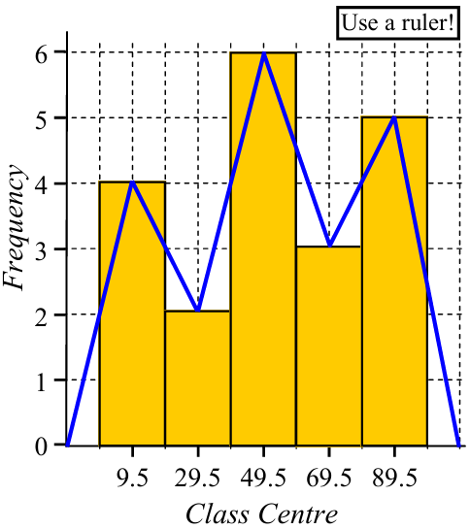  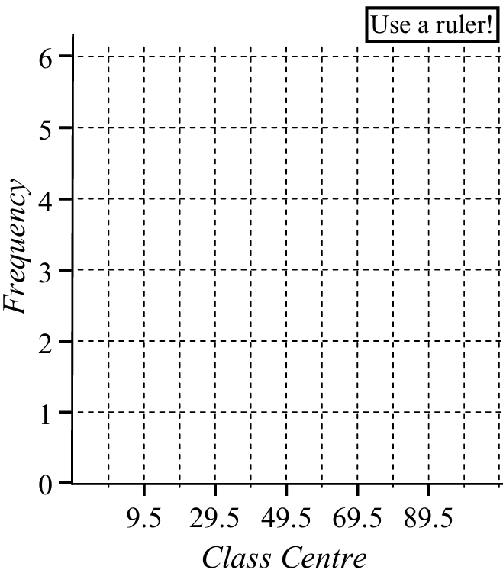  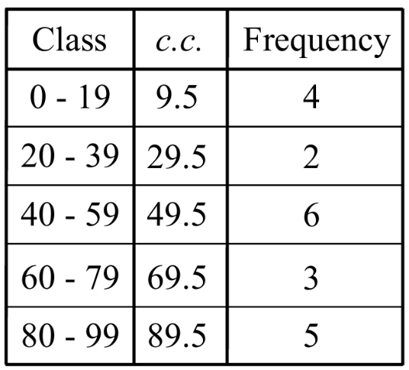 | 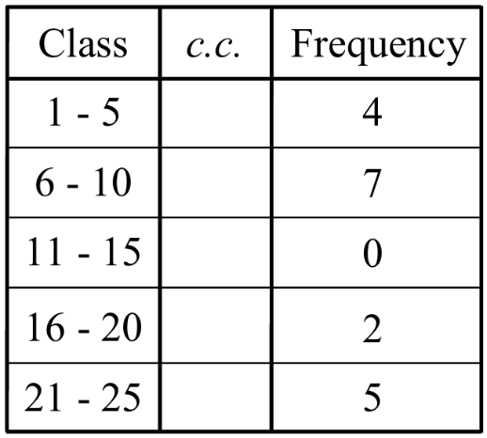  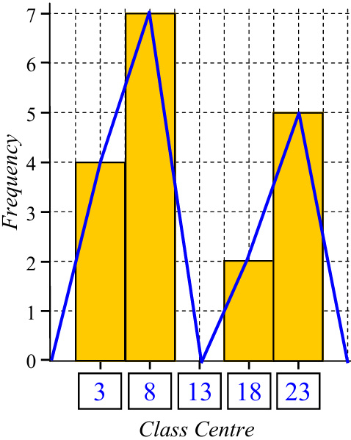  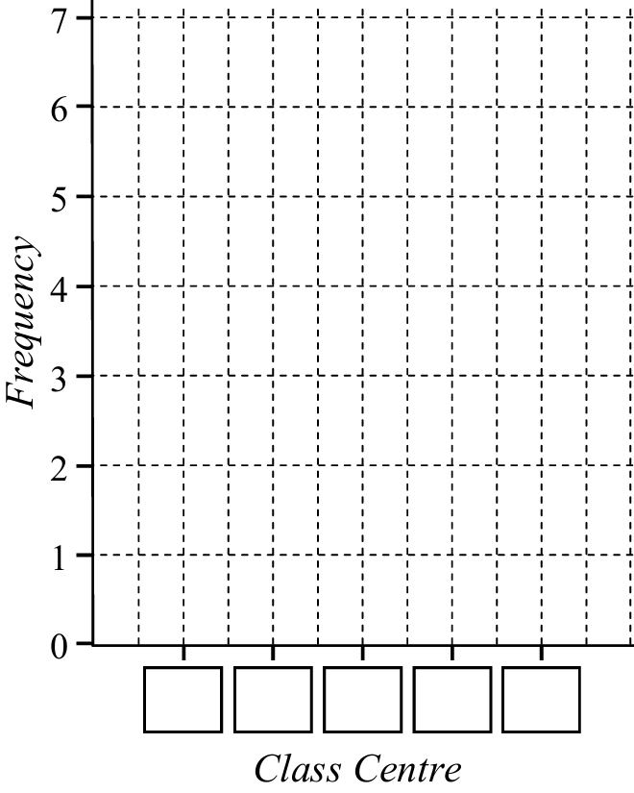

- Place the data in the frequency table, then draw the histogram and polygon.
63, 9, 33, 43, 9, 63, 10, 67, 54, 3, 68, 16, 56, 13, 21, 15, 4,
50, 58, 8, 4, 40, 48, 17, 65, 59, 10, 44, 50, 23, 26, 25, 37, 31
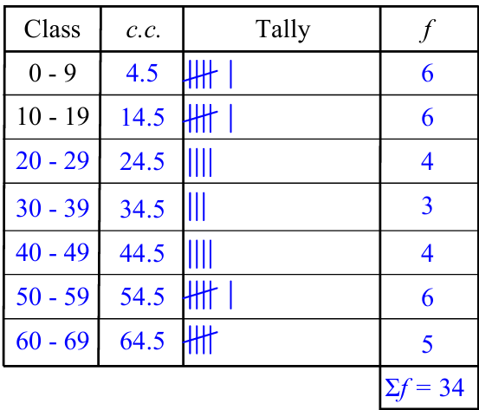
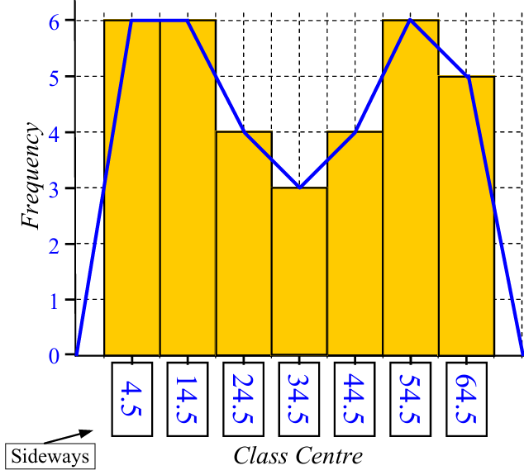
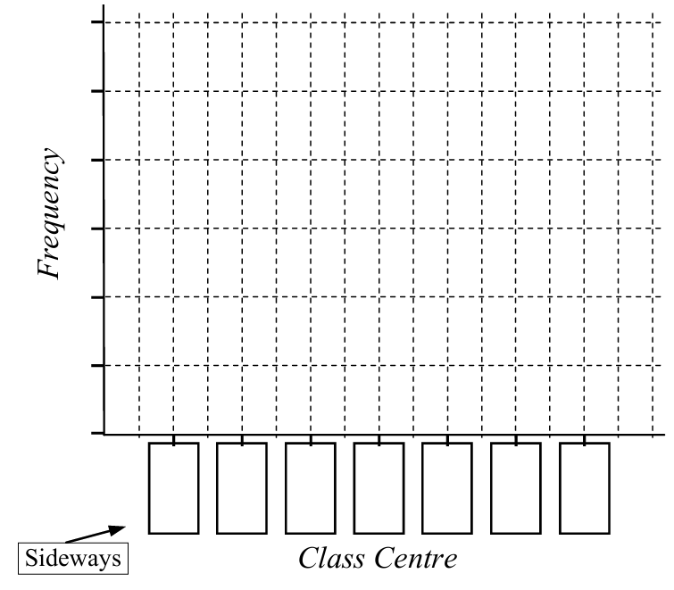
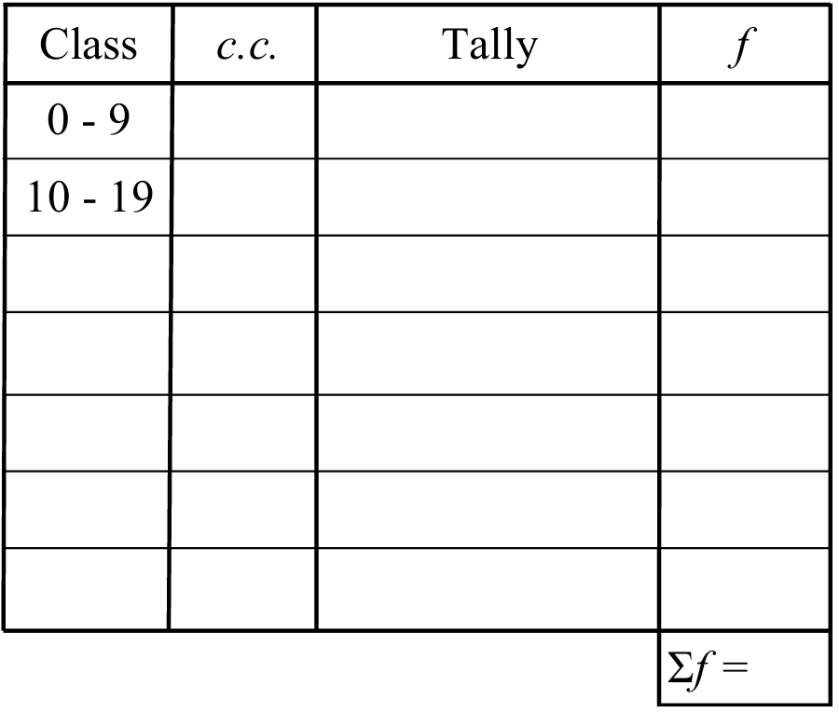

Development
- Construct a cumulative frequency histogram and ogive.
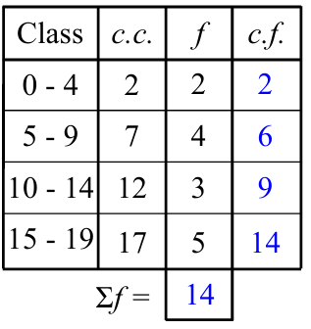
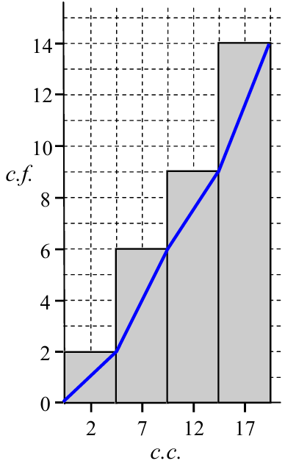
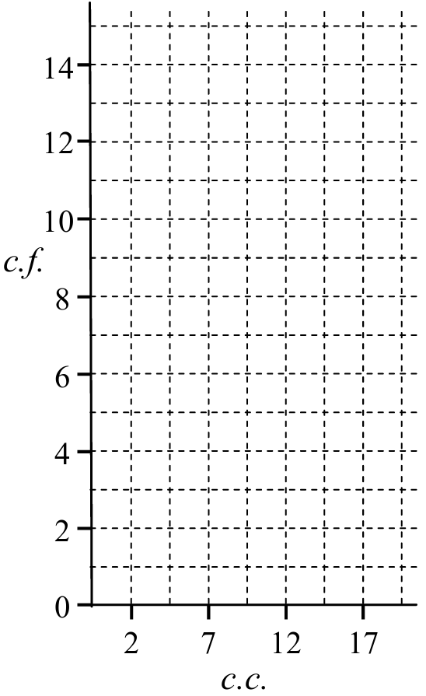
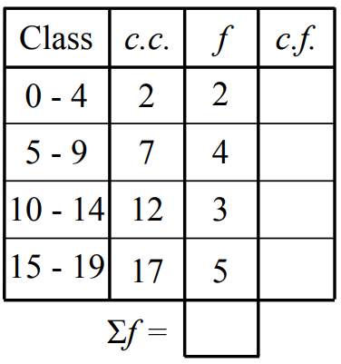

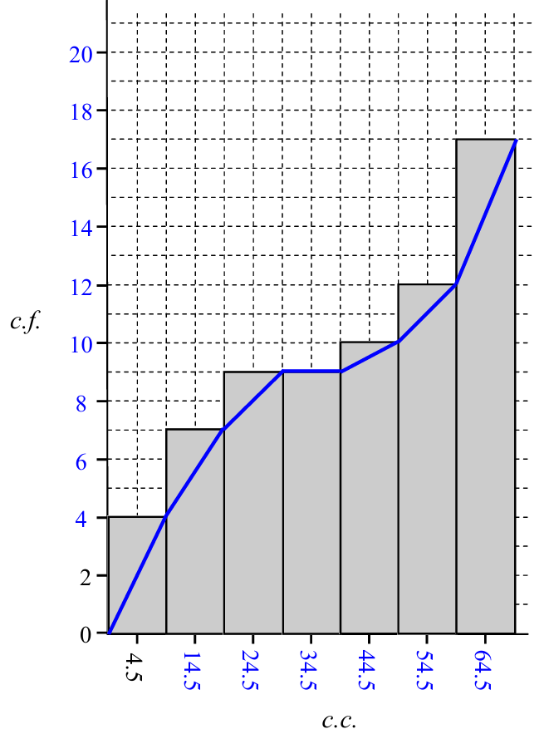
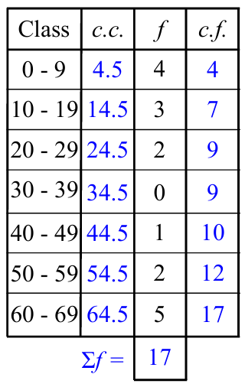
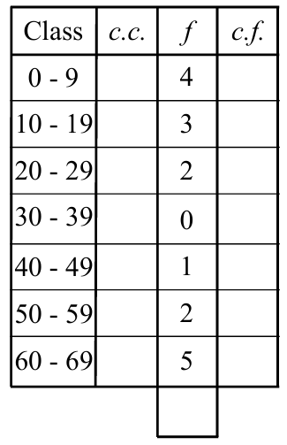
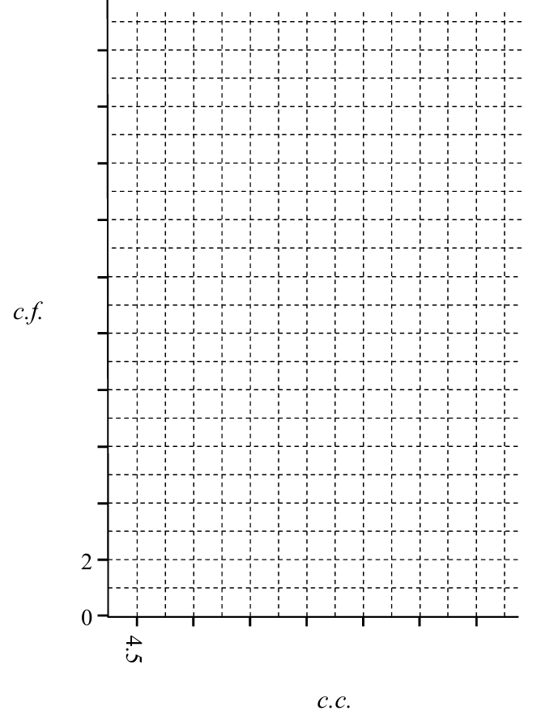

Mean and Median from Grouped Data

- Mean from Grouped Data
When grouping data, individual data points are lost.
Therefore, any calculation of mean and median will be an estimate.
Estimation of mean is the same as calculation from ungrouped data in tables, except we use the class centre.
- Find the class centres.
- Multiply the class centres and the frequencies $cc×f$
- Estimate the mean by dividing the sum of $cc×f$ by the total frequency $\overline{x}=\frac{Σ\left(cc×f\right)}{Σf}$

- Example Estimate mean from a grouped frequency table
Estimate the mean from this grouped frequency table:
Mass | Frequency | Class Centre | $$cc×f$$
$$40<m≤50$$ | 12 | 45 | 540
$$50<m≤60$$ | 18 | 55 | 990
$$60<m≤70$$ | 20 | 65 | 1300
$$70<m≤80$$ | 13 | 75 | 975
Total | 63 |  | 3805

$$\overline{x}=\frac{Σccf}{Σf}=\frac{3805}{63}=60.4$$

- Guided Practice
The grouped frequency table shows the lengths of time that a group of 150 people spent exercising last week.
Time (hrs) | Frequency | Class Centre | $$cc×f$$
$$0<t≤2$$ | 63 | 1 | 63
$$2<t≤4$$ | 15 | 3 | 45
$$4<t≤6$$ | 27 | 5
$$6<t≤8$$ | 24
$$8<t≤10$$ | 21
Total | 150

Complete the table to find an estimate of the mean time spent exercising last week.
$$\overline{x}=\frac{Σccf}{Σf}=$$

4
- Median from Grouped Data
Estimation of median is done using an ogive (cumulative frequency line).
Find the median position by finding 50% of the total cumulative frequency.
Draw a horizontal line from the median position to the ogive.
Read off the $x$-value; for grouped data, make an estimate.

- Example Estimate median from a cumulative frequency histogram
Estimate the median from this grouped frequency histogram:
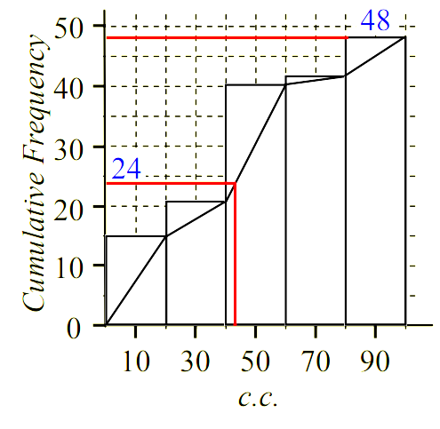
Total cumulative frequency is 48.
Median position is 24.

The median is 43.

- Guided Practice
Estimate the median from this grouped frequency histogram:

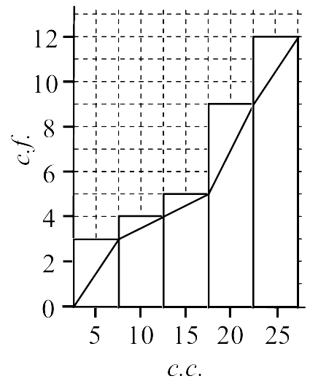
Total cumulative frequency is …………
Median position is …………

The median is: …………

19

Foundation
- Complete these grouped frequency tables to calculate the mean.
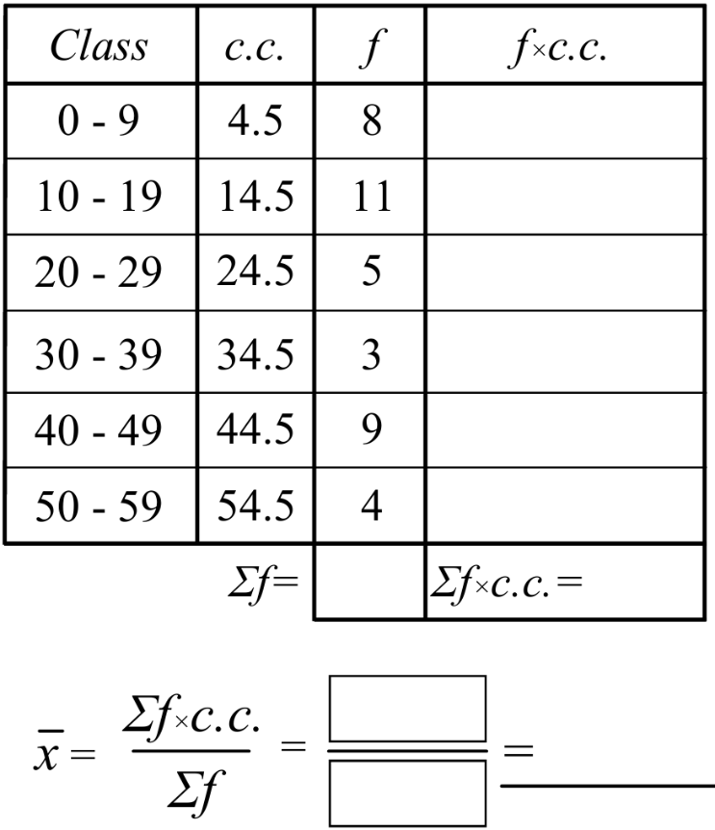  26 | 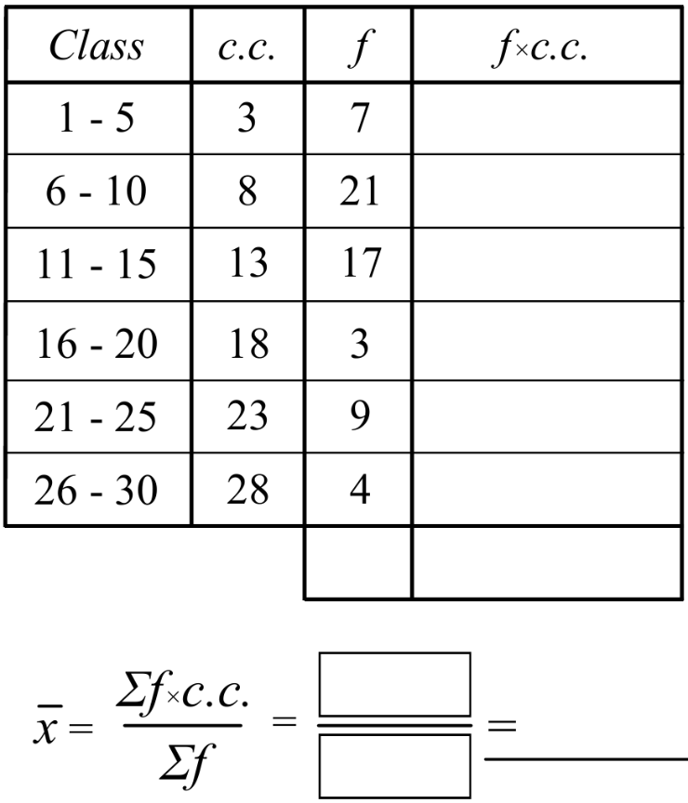  12.8

- Find the median from these cumulative frequency histograms and polygons with grouped data.
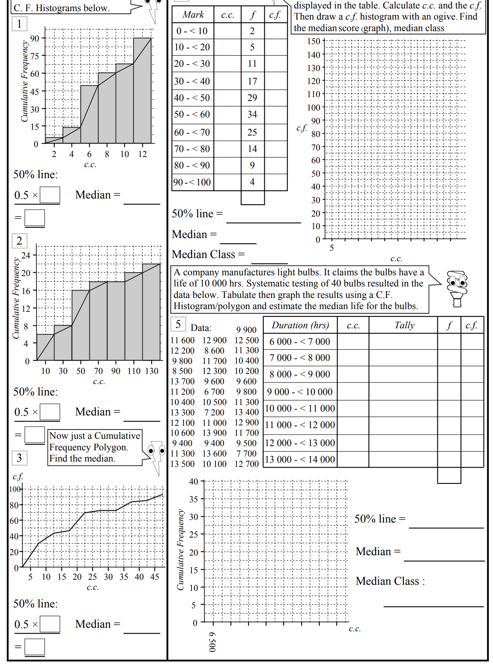  7 | 49 | 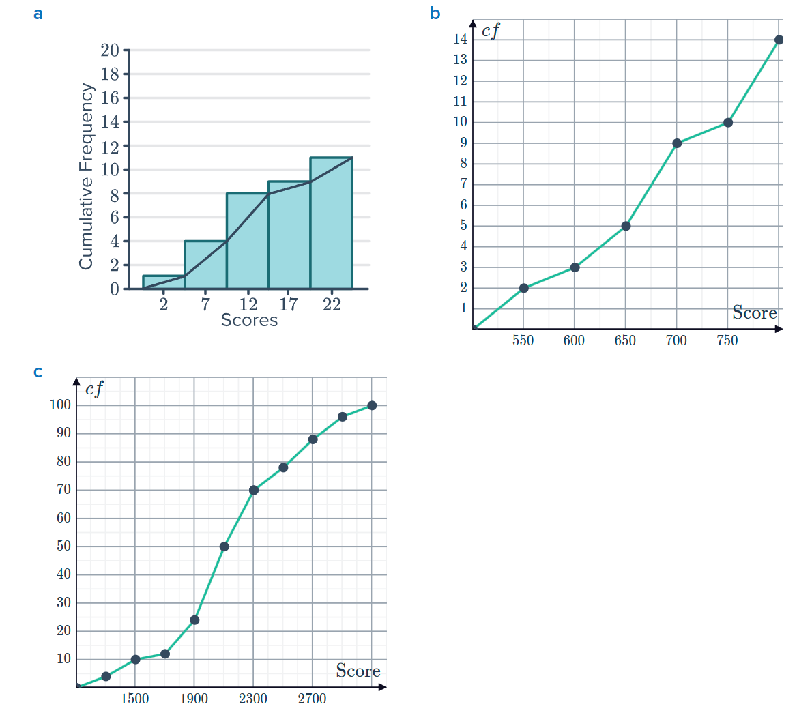  12
18 | 675 | 2100

- The table shows the heights of 100 students.
Height (cm) | Frequency | Class Centre | $$cc×f$$
$$150<m≤160$$ | 10
$$160<m≤170$$ | 27
$$170<m≤180$$ | 29
$$180<m≤190$$ | 22
$$190<m≤200$$ | 12
Total | 100

  - Complete the table to find an estimate of the mean height of the students.

174.9
  - Why is this an estimate?

We don’t know the exact value of the individual data values.

- Find the median from these grouped cumulative frequency histograms.
You will need to draw the ogive.
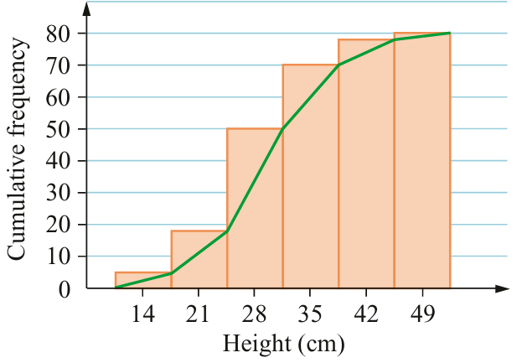  30 | 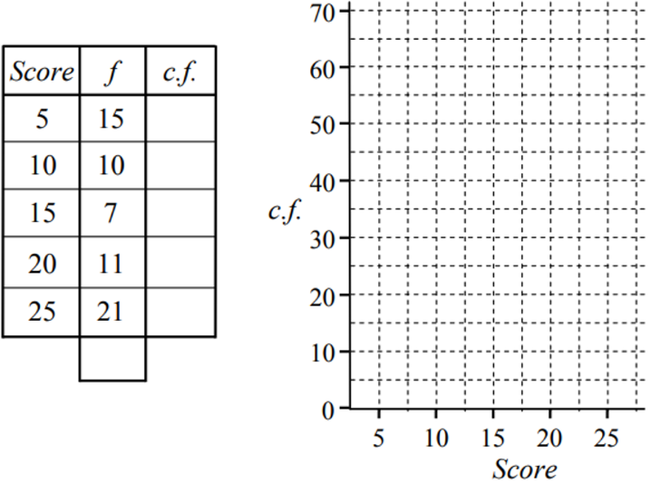  17.5

Development
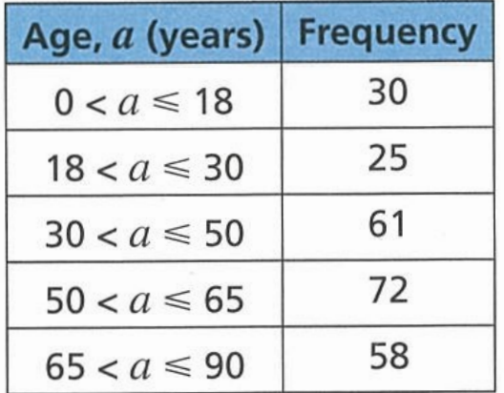
- The table shows information about the ages of visitors to an art gallery one day.

  - Estimate the mean age of the visitors to the art gallery.

48.6
  - State the modal class.

$$50<a≤65$$
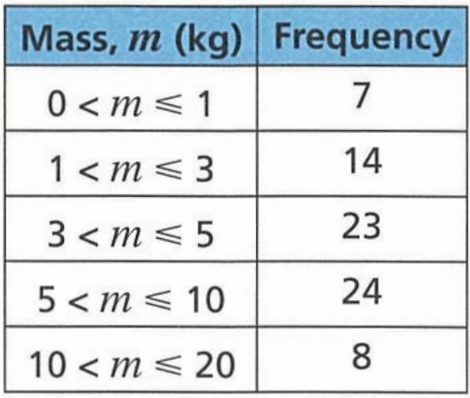
- A vet recorded the mass of each animal that came to the surgery one day.
The results are shown in the table.
Estimate the mean mass of the animals that came to the surgery that day.

5.57
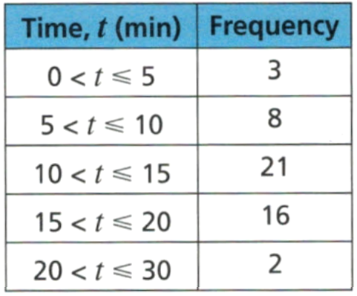
- The table shows the times that 50 patients waited at the dentist before their appointment.

Find an estimate for the mean time that these patients waited.

13.2

- Estimate the mean from these grouped frequency tables.
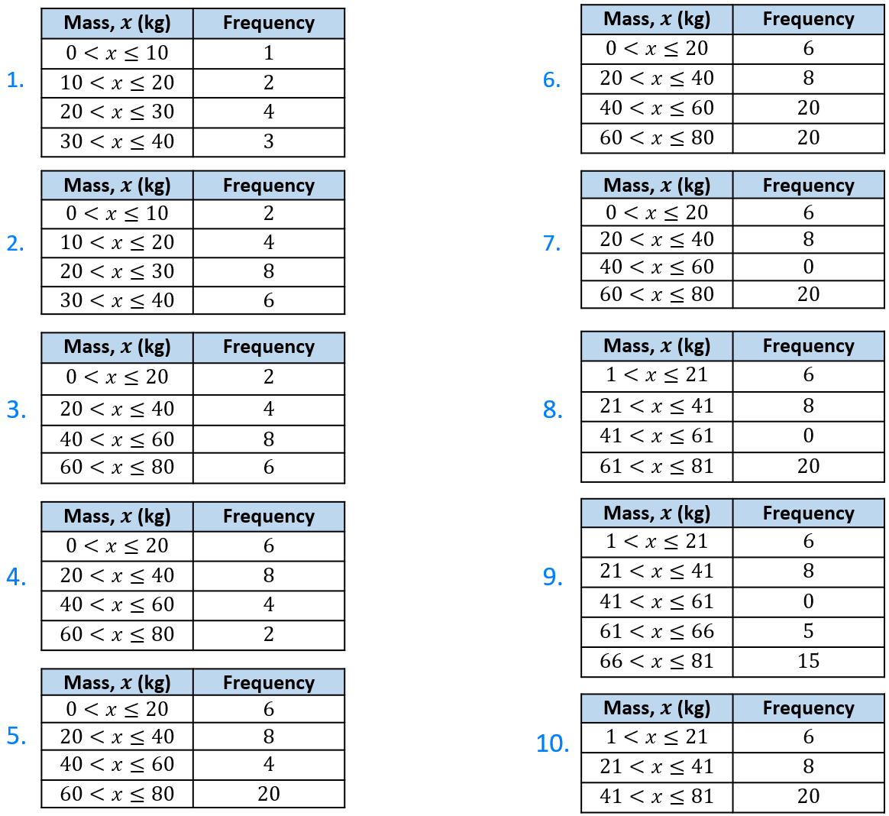  24 | 50
24 | 50
48 | 51
32 | 51
50 | 45.12

- 150 students sat a yearly exam. The results are shown in the table.
Draw a cumulative histogram and ogive, then estimate the median.
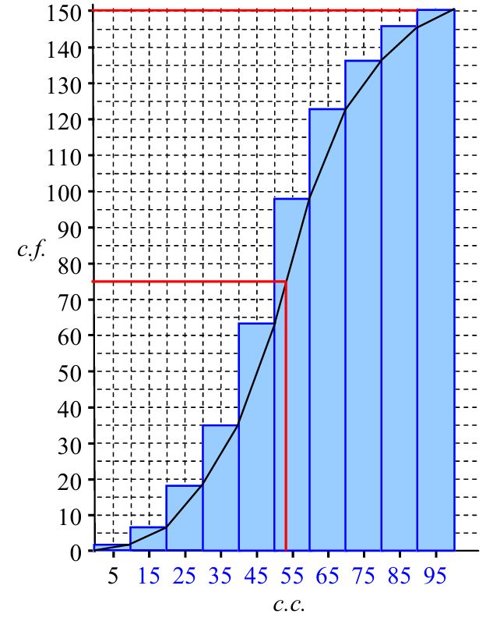
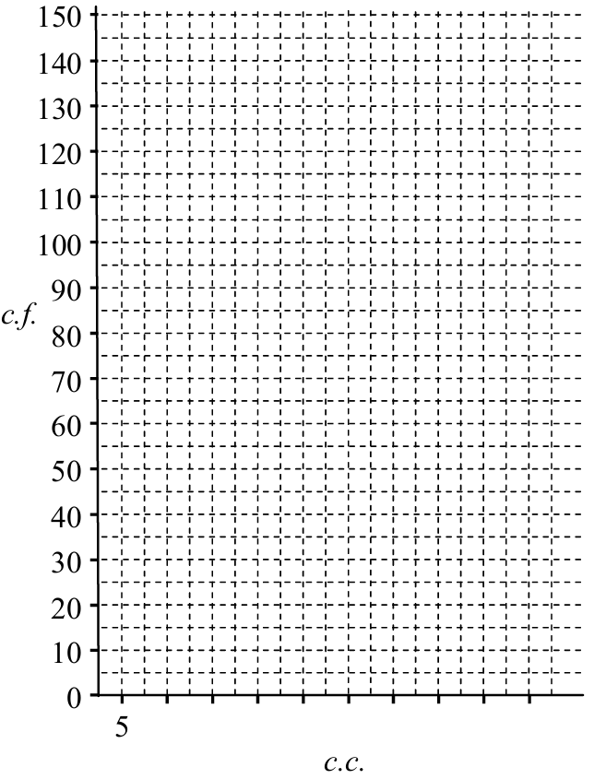
Mark | $$c.c.$$ | $$f$$ | $$c.f.$$
$$0≤x<10$$ |  | 2
$$10≤x<20$$ |  | 5
$$20≤x<30$$ |  | 11
$$30≤x<40$$ |  | 17
$$40≤x<50$$ |  | 29
$$50≤x<60$$ |  | 34
$$60≤x<70$$ |  | 25
$$70≤x<80$$ |  | 14
$$80≤x<90$$ |  | 9
$$90≤x<100$$ |  | 4
Total

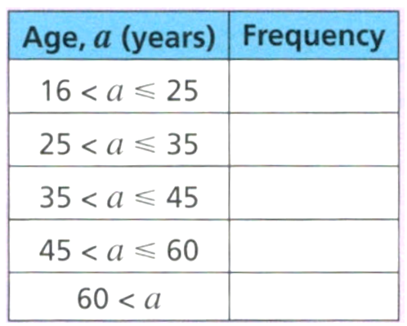
- The table shows the ages of people at a concert.
Why would it be difficult to find an estimate of the mean age for this data?

It is not possible to find the class centre for 60 < a

- Determine the IQR from these ogives.
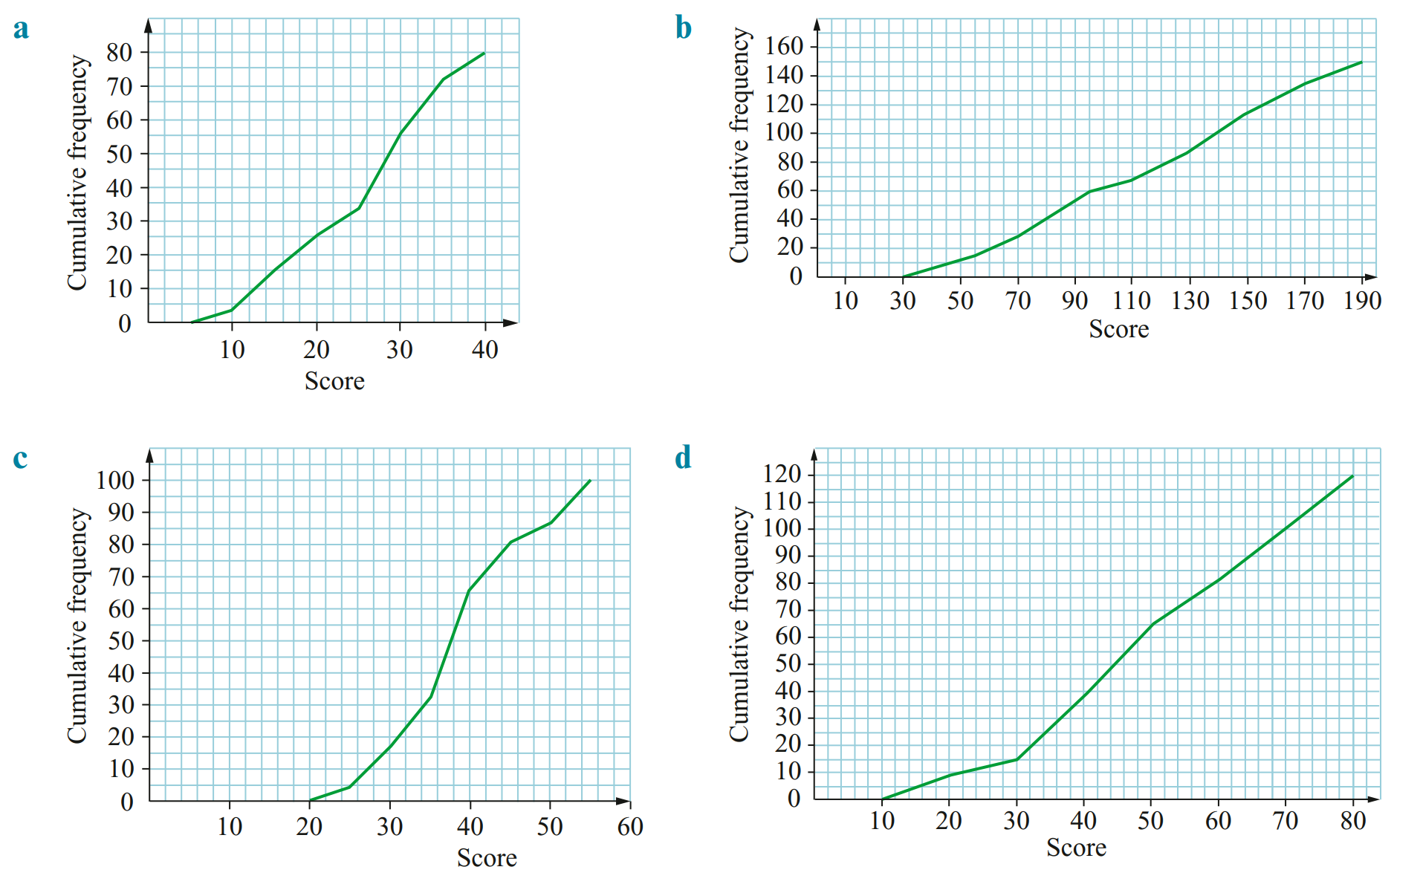  IQR = 31 – 17 = 14 | IQR = 145 – 75 = 70
IQR = 43 – 33 = 10 | IQR = 65 – 36 = 29
IQR = 90 – 57 = 33 | 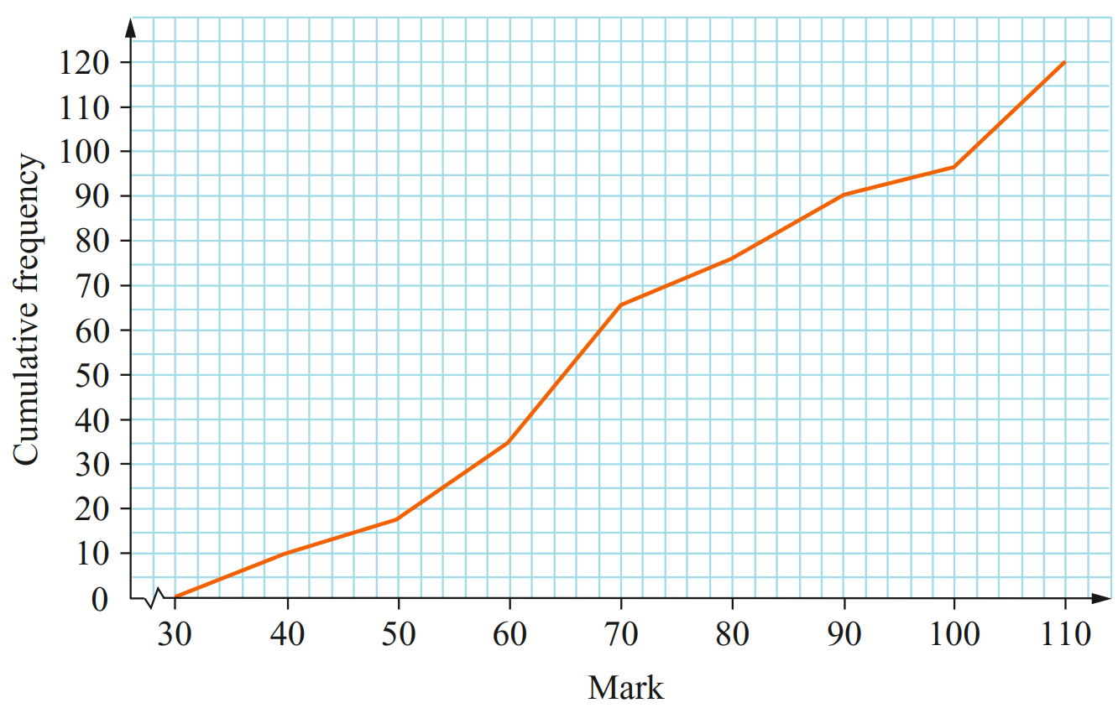  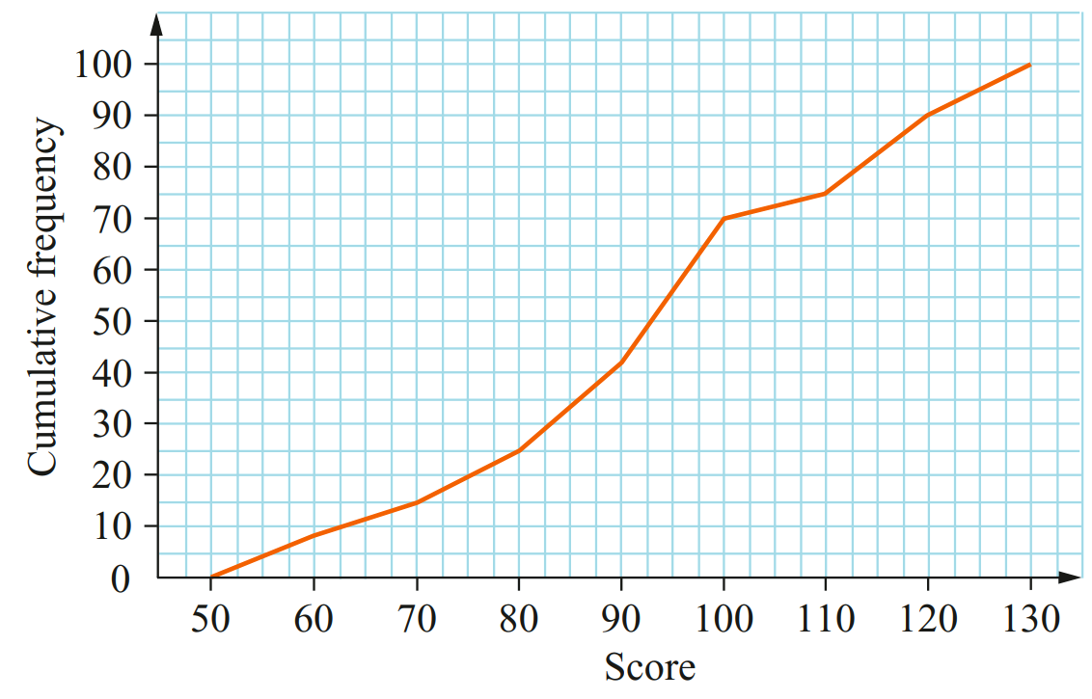  IQR = 110 – 80 = 30

Mastery
- 2023 HSC Standard 1
A company employs 50 people.
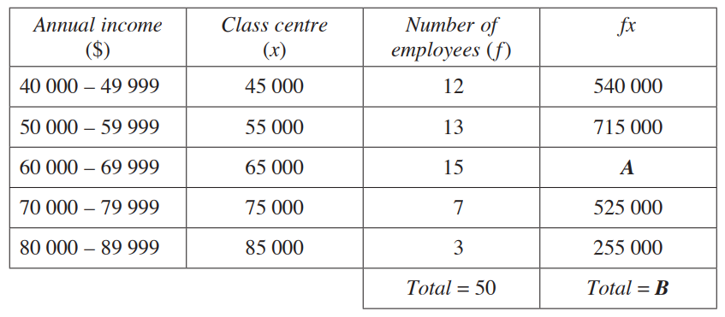
The annual income of the employees is shown in the grouped frequency distribution table.

What are the values of A and B?

A = $975 000; B = 3 010 000
Find the mean for this distribution.

$60 200
- 2014 HSC Standard 2 Band 5
Twenty Year 12 students were surveyed. These students were asked how many hours of sport they play per week, to the nearest hour.
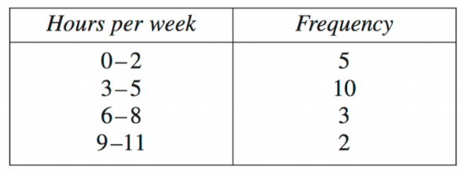
The results are shown in the frequency table.

What is the mean number of hours of sport played by the students per week?

4.3

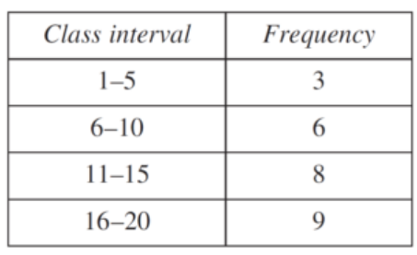
- 2016 HSC Standard 2 Band 5
A grouped frequency table is shown.

What is the mean for this set of data?

12.42

- The data below shows the value of cars sold at a dealership.
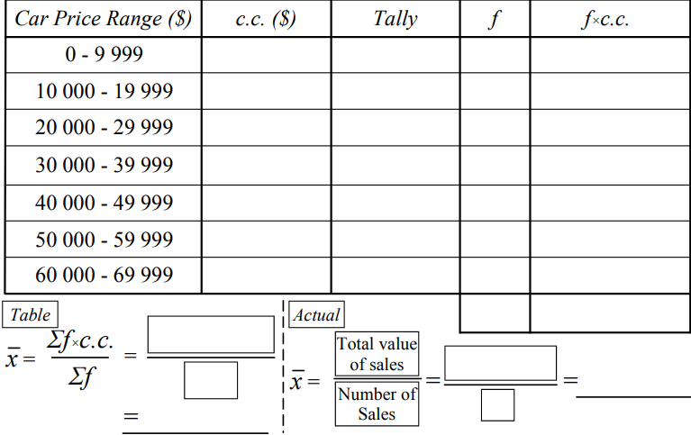
15 900, 34 500, 23 450, 9 999, 25 133, 47 900, 12 100, 28 888, 37 080, 55 600, 20 300,
47 122, 36 510, 14 068, 33 500, 45 770, 25 900, 65 000, 42 800, 11 550, 27 279, 53 211,
39 010, 17 800, 20 116, 37 080, 36 510, 39 888, 52 665, 19 995, 40750

Comment on the accuracy of the mean estimate from a grouped frequency table, compared to the actual mean.

The estimate is close. (32418.85 vs 32818.51)

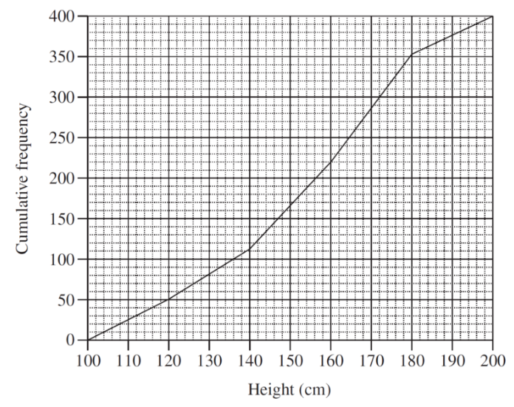
- 2016 HSC Standard 2 Band 5
The heights of 400 students were measured. The results are displayed in this cumulative frequency polygon. Use the polygon to estimate the interquartile range.

Using the cumulative frequency polygon ($n=400$):
$$Q1 is at \frac{400}{4}=100 \\ Q3 is at\frac{3}{4}×400=300$$
$$using graph, Q_{1}=136, Q_{3}=172$$
$$IQR=172-136=36$$

- 2018 HSC Standard 2 Band 5
A cumulative frequency table for a data set is shown. What is the interquartile range?
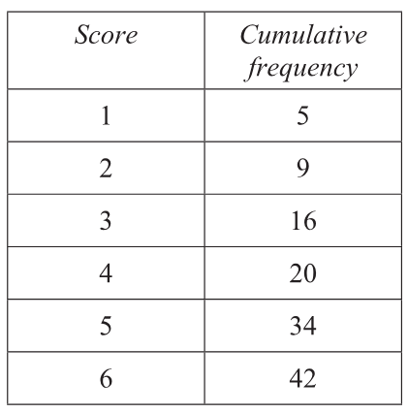
There are $42$ scores in total. The data can be split into two halves of $21$ scores each.
The lower quartile ($Q_{1}$) is the median of the first $21$ scores, which is the $11\text{th}$ score.
the $11\text{th}$ score falls in the score group $3$ (which contains the $10\text{th}$ to $16\text{th}$ scores).
So, $Q_{1}=3$.
The upper quartile ($Q_{3}$) is the median of the second half of scores,
which is the $11\text{th}$ score of the second half, or the $32\text{nd}$ score overall.
the $32\text{nd}$ score falls in the score group $5$ (which contains the $21\text{st}$ to $34\text{th}$ scores).
So, $Q_{3}=5$.
$$\begin{matrix}\text{Interquartile range (IQR)} & =Q_{3}-Q_{1} \\ & =5-3 \\ & =2\end{matrix}$$
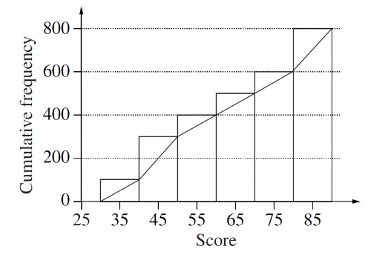
- 2005 HSC Standard 2 Band 5
A set of data is represented by the cumulative frequency histogram and ogive.
What is the best approximation for the interquartile range for this set of data?
The total cumulative frequency is $800$.
$$\begin{matrix}Q_{1}\text{ is at }\frac{800}{4} & =200 \\ Q_{3}\text{ is at }\frac{3×800}{4} & =600\end{matrix}$$Reading from the ogive:
- A cumulative frequency of $200$ corresponds to a score of $45$.
- A cumulative frequency of $600$ corresponds to a score of 80.
$$\begin{matrix}\text{Interquartile range} & =Q_{3}-Q_{1} \\ & =80-45 \\ & =35\end{matrix}$$

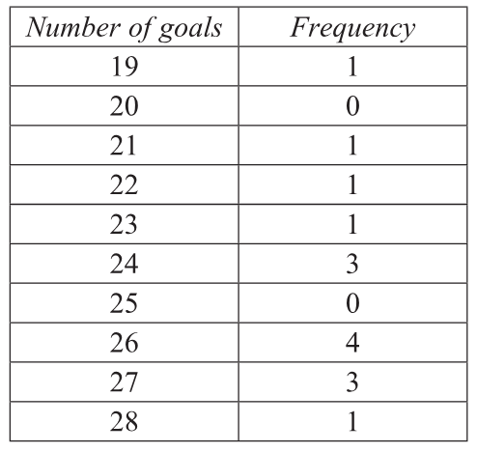
- 2019 HSC Standard 2 Band 5
Two netball teams, Team A and Team B, each played 15 games in a tournament.
For each team, the number of goals scored in each game was recorded.
The frequency table shows the data for Team A.
The data for team B was analysed to create the box plot.

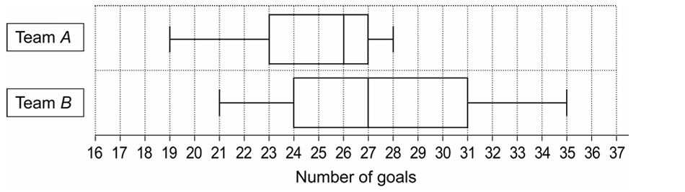
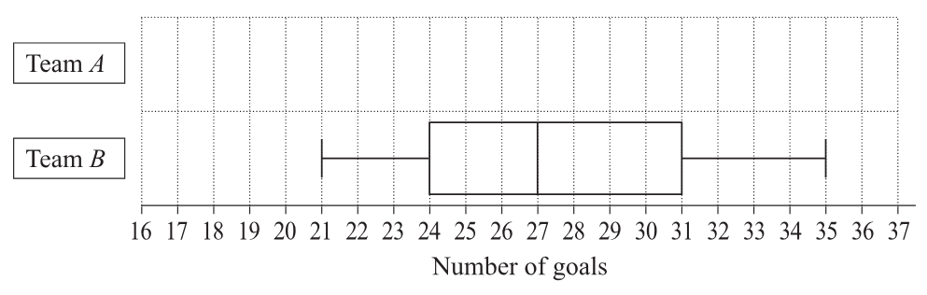

Compare the distributions of the number of goals scored by the two teams.
Support your answer with the construction of a box-plot for the data for Team A.

First, find the five-number summary for Team A (15 scores):
Minimum = 19
Maximum = 28
Median = the 8th score. Counting frequencies: 19(1), 21(1), 22(1), 23(1), 24(3) -> 7 scores. The 8th score is 26. So, Median = 26.
$Q_{1}$ is the median of the lower 7 scores. The 4th score is 23. So, $Q_{1}=23$.
$Q_{3}$ is the median of the upper 7 scores. The 12th score is 27. So, $Q_{3}=27$.
Alternatively you can use a calculator to find the five-number summary.
Comparing the distributions:
- Central Tendency: Team B generally scores more goals per game than Team A, as Team B has a higher median ($27$ compared to $26$).
- Spread: Team A is more consistent in the number of goals scored per game. This is shown by the smaller Interquartile Range ($27-23=4$ for A, compared to $31-24=7$ for B) and a smaller overall range ($28-19=9$ for A, compared to $35-21=14$ for B).
- Skewness: Team A's distribution is negatively skewed (the left tail and box section are longer), whereas Team B's distribution is relatively symmetrical or slightly positively skewed.

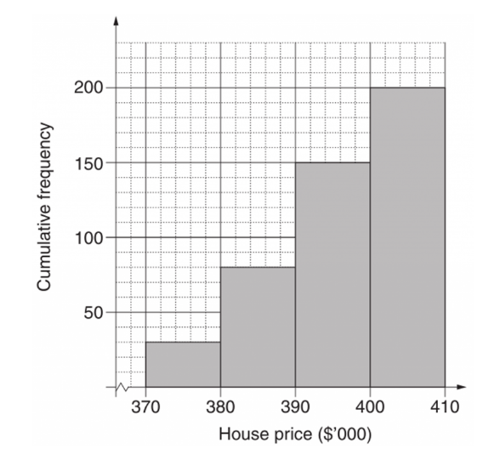
- 2015 HSC Standard 2 Band 6
Data from 200 recent house sales are grouped into class intervals and a cumulative frequency histogram is drawn.

  - Use the graph to estimate the median house price.

$≈$ $392 500
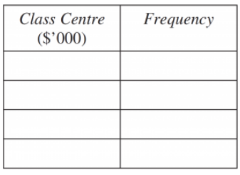
  - By completing the table,
calculate the mean house price.

$392 000

- 2013 HSC Standard 2 Band 6
A retailer has collected data on the number of televisions that he sold each week in 2012.
He grouped the data into classes and displayed the data using a cumulative frequency histogram and polygon (ogive).
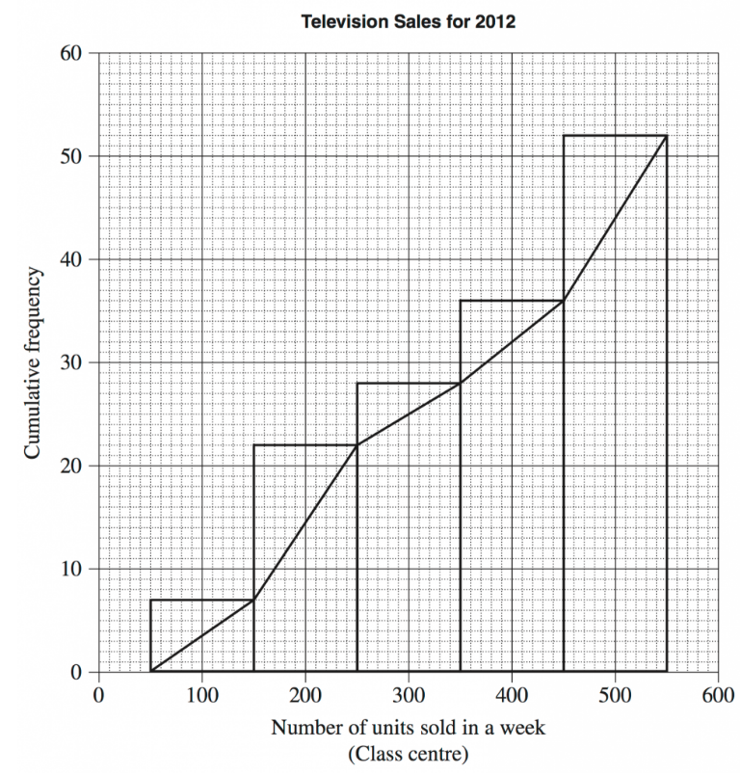
  - Use the cumulative frequency polygon to determine the interquartile range.

Total number of data values is 52.
Position of Q1 is 13, Position of Q3 is 39
Q1 = 190
Q3 = 470
IQR = 280
  - Oscar said that the retailer sold 300 televisions in 6 of the weeks in 2012. Is he correct? Give a reason for your answer.

No. The data is grouped. He can only say the retailer sold between 250 and 350 units, not exactly 300.

